Building applications
An application consists of a number of files:
The binary | This gets installed in /usr/bin.
A desktop file | The desktop file provides important information about the application to the desktop shell, such as its name, icon, D-Bus name, commandline to launch it, etc. It is installed in /usr/share/applications.
An icon | The icon gets installed in /usr/share/icons/hicolor/48x48/apps, where it will be found regardless of the current theme.
A settings schema | If the application uses GSettings, it will install its schema in /usr/share/glib-2.0/schemas, so that tools like dconf-editor can find it.
Other resources | Other files, such as GtkBuilder ui files, are best loaded from resources stored in the application binary itself. This eliminates the need for most of the files that would traditionally be installed in an application-specific location in /usr/share.
GTK+ includes application support that is built on top of GApplication. In this tutorial we'll build a simple application by starting from scratch, adding more and more pieces over time. Along the way, we'll learn about GtkApplication, templates, resources, application menus, settings, GtkHeaderBar, GtkStack, GtkSearchBar, GtkListBox, and more.
The full, buildable sources for these examples can be found in the examples/ directory of the GTK+ source distribution, or online in the GTK+ git repository. You can build each example separately by using make with the Makefile.example file. For more information, see the README included in the examples directory.

A trivial application
When using GtkApplication, the main() function can be very simple. We just call g_application_run() and give it an instance of our application class.
#include <gtk/gtk.h>

#include "exampleapp.h"

int
main (int argc, char *argv[])
{
return g_application_run (G_APPLICATION (example_app_new ()), argc, argv);
}
All the application logic is in the application class, which is a subclass of GtkApplication. Our example does not yet have any interesting functionality. All it does is open a window when it is activated without arguments, and open the files it is given, if it is started with arguments.
To handle these two cases, we override the activate() vfunc, which gets called when the application is launched without commandline arguments, and the open() vfunc, which gets called when the application is launched with commandline arguments.
To learn more about GApplication entry points, consult the GIO documentation.
#include <gtk/gtk.h>

#include "exampleapp.h"
#include "exampleappwin.h"

struct _ExampleApp
{
GtkApplication parent;
};

G_DEFINE_TYPE(ExampleApp, example_app, GTK_TYPE_APPLICATION);

static void
example_app_init (ExampleApp *app)
{
}

static void
example_app_activate (GApplication *app)
{
ExampleAppWindow *win;

win = example_app_window_new (EXAMPLE_APP (app));
gtk_window_present (GTK_WINDOW (win));
}

static void
example_app_open (GApplication *app,
GFile **files,
gint n_files,
const gchar *hint)
{
GList *windows;
ExampleAppWindow *win;
int i;

windows = gtk_application_get_windows (GTK_APPLICATION (app));
if (windows)
win = EXAMPLE_APP_WINDOW (windows->data);
else
win = example_app_window_new (EXAMPLE_APP (app));

for (i = 0; i < n_files; i++)
example_app_window_open (win, files[i]);

gtk_window_present (GTK_WINDOW (win));
}

static void
example_app_class_init (ExampleAppClass *class)
{
G_APPLICATION_CLASS (class)->activate = example_app_activate;
G_APPLICATION_CLASS (class)->open = example_app_open;
}

ExampleApp *
example_app_new (void)
{
return g_object_new (EXAMPLE_APP_TYPE,
"application-id", "org.gtk.exampleapp",
"flags", G_APPLICATION_HANDLES_OPEN,
NULL);
}
Another important class that is part of the application support in GTK+ is GtkApplicationWindow. It is typically subclassed as well. Our subclass does not do anything yet, so we will just get an empty window.
#include <gtk/gtk.h>

#include "exampleapp.h"
#include "exampleappwin.h"

struct _ExampleAppWindow
{
GtkApplicationWindow parent;
};

G_DEFINE_TYPE(ExampleAppWindow, example_app_window, GTK_TYPE_APPLICATION_WINDOW);

static void
example_app_window_init (ExampleAppWindow *app)
{
}

static void
example_app_window_class_init (ExampleAppWindowClass *class)
{
}

ExampleAppWindow *
example_app_window_new (ExampleApp *app)
{
return g_object_new (EXAMPLE_APP_WINDOW_TYPE, "application", app, NULL);
}

void
example_app_window_open (ExampleAppWindow *win,
GFile *file)
{
}
As part of the initial setup of our application, we also create an icon and a desktop file.

[Desktop Entry]
Type=Application
Name=Example
Icon=exampleapp
StartupNotify=true
Exec=@bindir@/exampleapp
Note that @bindir@ needs to be replaced with the actual path to the binary before this desktop file can be used.
Here is what we've achieved so far:

This does not look very impressive yet, but our application is already presenting itself on the session bus, it has single-instance semantics, and it accepts files as commandline arguments.

Populating the window
In this step, we use a GtkBuilder template to associate a GtkBuilder ui file with our application window class.
Our simple ui file puts a GtkHeaderBar on top of a GtkStack widget. The header bar contains a GtkStackSwitcher, which is a standalone widget to show a row of 'tabs' for the pages of a GtkStack.
<?xml version="1.0" encoding="UTF-8"?>
<interface>
<!-- interface-requires gtk+ 3.8 -->
<template class="ExampleAppWindow" parent="GtkApplicationWindow">
<property name="title" translatable="yes">Example Application</property>
<property name="default-width">600</property>
<property name="default-height">400</property>
<child>
<object class="GtkBox" id="content_box">
<property name="visible">True</property>
<property name="orientation">vertical</property>
<child>
<object class="GtkHeaderBar" id="header">
<property name="visible">True</property>
<child type="title">
<object class="GtkStackSwitcher" id="tabs">
<property name="visible">True</property>
<property name="stack">stack</property>
</object>
</child>
</object>
</child>
<child>
<object class="GtkStack" id="stack">
<property name="visible">True</property>
</object>
</child>
</object>
</child>
</template>
</interface>
To make use of this file in our application, we revisit our GtkApplicationWindow subclass, and call gtk_widget_class_set_template_from_resource() from the class init function to set the ui file as template for this class. We also add a call to gtk_widget_init_template() in the instance init function to instantiate the template for each instance of our class.
...

static void
example_app_window_init (ExampleAppWindow *win)
{
gtk_widget_init_template (GTK_WIDGET (win));
}

static void
example_app_window_class_init (ExampleAppWindowClass *class)
{
gtk_widget_class_set_template_from_resource (GTK_WIDGET_CLASS (class),
"/org/gtk/exampleapp/window.ui");
}

...

(full source)
You may have noticed that we used the _from_resource() variant of the function that sets a template. Now we need to use GLib's resource functionality to include the ui file in the binary. This is commonly done by listing all resources in a .gresource.xml file, such as this:
<?xml version="1.0" encoding="UTF-8"?>
<gresources>
<gresource prefix="/org/gtk/exampleapp">
<file preprocess="xml-stripblanks">window.ui</file>
</gresource>
</gresources>
This file has to be converted into a C source file that will be compiled and linked into the application together with the other source files. To do so, we use the glib-compile-resources utility:
glib-compile-resources exampleapp.gresource.xml --target=resources.c --generate-source

Our application now looks like this:
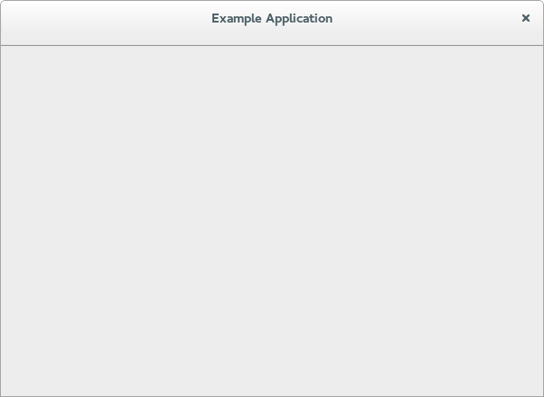

Opening files
In this step, we make our application show the content of all the files that it is given on the commandline.
To this end, we add a private struct to our application window subclass and keep a reference to the GtkStack there. The gtk_widget_class_bind_template_child_private() function arranges things so that after instantiating the template, the stack member of the private struct will point to the widget of the same name from the template.
...

struct _ExampleAppWindowPrivate
{
GtkWidget *stack;
};

G_DEFINE_TYPE_WITH_PRIVATE(ExampleAppWindow, example_app_window, GTK_TYPE_APPLICATION_WINDOW);

...

static void
example_app_window_class_init (ExampleAppWindowClass *class)
{
gtk_widget_class_set_template_from_resource (GTK_WIDGET_CLASS (class),
"/org/gtk/exampleapp/window.ui");
gtk_widget_class_bind_template_child_private (GTK_WIDGET_CLASS (class), ExampleAppWindow, stack);
}

...

(full source)
Now we revisit the example_app_window_open() function that is called for each commandline argument, and construct a GtkTextView that we then add as a page to the stack:
...

void
example_app_window_open (ExampleAppWindow *win,
GFile *file)
{
ExampleAppWindowPrivate *priv;
gchar *basename;
GtkWidget *scrolled, *view;
gchar *contents;
gsize length;

priv = example_app_window_get_instance_private (win);
basename = g_file_get_basename (file);

scrolled = gtk_scrolled_window_new (NULL, NULL);
gtk_widget_show (scrolled);
gtk_widget_set_hexpand (scrolled, TRUE);
gtk_widget_set_vexpand (scrolled, TRUE);
view = gtk_text_view_new ();
gtk_text_view_set_editable (GTK_TEXT_VIEW (view), FALSE);
gtk_text_view_set_cursor_visible (GTK_TEXT_VIEW (view), FALSE);
gtk_widget_show (view);
gtk_container_add (GTK_CONTAINER (scrolled), view);
gtk_stack_add_titled (GTK_STACK (priv->stack), scrolled, basename, basename);

if (g_file_load_contents (file, NULL, &contents, &length, NULL, NULL))
{
GtkTextBuffer *buffer;

buffer = gtk_text_view_get_buffer (GTK_TEXT_VIEW (view));
gtk_text_buffer_set_text (buffer, contents, length);
g_free (contents);
}

g_free (basename);
}

...

(full source)
Note that we did not have to touch the stack switcher at all. It gets all its information from the stack that it belongs to. Here, we are passing the label to show for each file as the last argument to the gtk_stack_add_titled() function.
Our application is beginning to take shape:
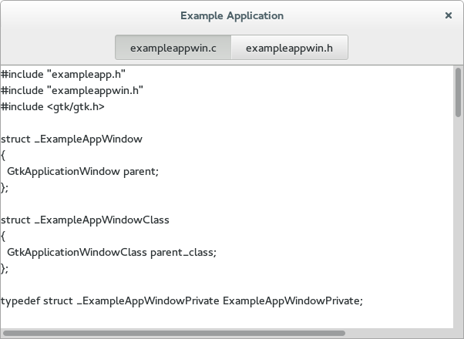

An application menu
An application menu is shown by GNOME shell at the top of the screen. It is meant to collect infrequently used actions that affect the whole application.
Just like the window template, we specify our application menu in a ui file, and add it as a resource to our binary.
<?xml version="1.0"?>
<interface>
<!-- interface-requires gtk+ 3.0 -->
<menu id="appmenu">
<section>
<item>
<attribute name="label" translatable="yes">_Preferences</attribute>
<attribute name="action">app.preferences</attribute>
</item>
</section>
<section>
<item>
<attribute name="label" translatable="yes">_Quit</attribute>
<attribute name="action">app.quit</attribute>
</item>
</section>
</menu>
</interface>
To associate the app menu with the application, we have to call gtk_application_set_app_menu(). Since app menus work by activating GActions, we also have to add a suitable set of actions to our application.
Both of these tasks are best done in the startup() vfunc, which is guaranteed to be called once for each primary application instance:
...

static void
preferences_activated (GSimpleAction *action,
GVariant *parameter,
gpointer app)
{
}

static void
quit_activated (GSimpleAction *action,
GVariant *parameter,
gpointer app)
{
g_application_quit (G_APPLICATION (app));
}

static GActionEntry app_entries[] =
{
{ "preferences", preferences_activated, NULL, NULL, NULL },
{ "quit", quit_activated, NULL, NULL, NULL }
};

static void
example_app_startup (GApplication *app)
{
GtkBuilder *builder;
GMenuModel *app_menu;
const gchar *quit_accels[2] = { "<Ctrl>Q", NULL };

G_APPLICATION_CLASS (example_app_parent_class)->startup (app);

g_action_map_add_action_entries (G_ACTION_MAP (app),
app_entries, G_N_ELEMENTS (app_entries),
app);
gtk_application_set_accels_for_action (GTK_APPLICATION (app),
"app.quit",
quit_accels);

builder = gtk_builder_new_from_resource ("/org/gtk/exampleapp/app-menu.ui");
app_menu = G_MENU_MODEL (gtk_builder_get_object (builder, "appmenu"));
gtk_application_set_app_menu (GTK_APPLICATION (app), app_menu);
g_object_unref (builder);
}

static void
example_app_class_init (ExampleAppClass *class)
{
G_APPLICATION_CLASS (class)->startup = example_app_startup;
...
}

...

(full source)
Our preferences menu item does not do anything yet, but the Quit menu item is fully functional. Note that it can also be activated by the usual Ctrl-Q shortcut. The shortcut was added with gtk_application_set_accels_for_action().
The application menu looks like this:
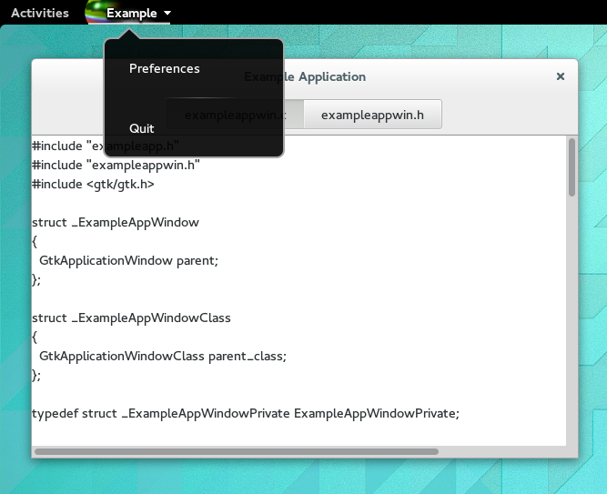

A preference dialog
A typical application will have a some preferences that should be remembered from one run to the next. Even for our simple example application, we may want to change the font that is used for the content.
We are going to use GSettings to store our preferences. GSettings requires a schema that describes our settings:
<?xml version="1.0" encoding="UTF-8"?>
<schemalist>
<schema path="/org/gtk/exampleapp/" id="org.gtk.exampleapp">
<key name="font" type="s">
<default>'Monospace 12'</default>
<summary>Font</summary>
<description>The font to be used for content.</description>
</key>
<key name="transition" type="s">
<choices>
<choice value='none'/>
<choice value='crossfade'/>
<choice value='slide-left-right'/>
</choices>
<default>'none'</default>
<summary>Transition</summary>
<description>The transition to use when switching tabs.</description>
</key>
</schema>
</schemalist>
Before we can make use of this schema in our application, we need to compile it into the binary form that GSettings expects. GIO provides macros to do this in autotools-based projects.
Next, we need to connect our settings to the widgets that they are supposed to control. One convenient way to do this is to use GSettings bind functionality to bind settings keys to object properties, as we do here for the transition setting.
...

static void
example_app_window_init (ExampleAppWindow *win)
{
ExampleAppWindowPrivate *priv;

priv = example_app_window_get_instance_private (win);
gtk_widget_init_template (GTK_WIDGET (win));
priv->settings = g_settings_new ("org.gtk.exampleapp");

g_settings_bind (priv->settings, "transition",
priv->stack, "transition-type",
G_SETTINGS_BIND_DEFAULT);
}

...

(full source)
The code to connect the font setting is a little more involved, since there is no simple object property that it corresponds to, so we are not going to go into that here.
At this point, the application will already react if you change one of the settings, e.g. using the gsettings commandline tool. Of course, we expect the application to provide a preference dialog for these. So lets do that now. Our preference dialog will be a subclass of GtkDialog, and we'll use the same techniques that we've already seen: templates, private structs, settings bindings.
Lets start with the template.
<?xml version="1.0" encoding="UTF-8"?>
<interface>
<!-- interface-requires gtk+ 3.8 -->
<template class="ExampleAppPrefs" parent="GtkDialog">
<property name="title" translatable="yes">Preferences</property>
<property name="resizable">False</property>
<property name="modal">True</property>
<child internal-child="vbox">
<object class="GtkBox" id="vbox">
<child>
<object class="GtkGrid" id="grid">
<property name="visible">True</property>
<property name="margin">6</property>
<property name="row-spacing">12</property>
<property name="column-spacing">6</property>
<child>
<object class="GtkLabel" id="fontlabel">
<property name="visible">True</property>
<property name="label">_Font:</property>
<property name="use-underline">True</property>
<property name="mnemonic-widget">font</property>
<property name="xalign">1</property>
</object>
<packing>
<property name="left-attach">0</property>
<property name="top-attach">0</property>
</packing>
</child>
<child>
<object class="GtkFontButton" id="font">
<property name="visible">True</property>
</object>
<packing>
<property name="left-attach">1</property>
<property name="top-attach">0</property>
</packing>
</child>
<child>
<object class="GtkLabel" id="transitionlabel">
<property name="visible">True</property>
<property name="label">_Transition:</property>
<property name="use-underline">True</property>
<property name="mnemonic-widget">transition</property>
<property name="xalign">1</property>
</object>
<packing>
<property name="left-attach">0</property>
<property name="top-attach">1</property>
</packing>
</child>
<child>
<object class="GtkComboBoxText" id="transition">
<property name="visible">True</property>
<items>
<item translatable="yes" id="none">None</item>
<item translatable="yes" id="crossfade">Fade</item>
<item translatable="yes" id="slide-left-right">Slide</item>
</items>
</object>
<packing>
<property name="left-attach">1</property>
<property name="top-attach">1</property>
</packing>
</child>
</object>
</child>
</object>
</child>
</template>
</interface>
Next comes the dialog subclass.
#include <gtk/gtk.h>

#include "exampleapp.h"
#include "exampleappwin.h"
#include "exampleappprefs.h"

struct _ExampleAppPrefs
{
GtkDialog parent;
};

typedef struct _ExampleAppPrefsPrivate ExampleAppPrefsPrivate;

struct _ExampleAppPrefsPrivate
{
GSettings *settings;
GtkWidget *font;
GtkWidget *transition;
};

G_DEFINE_TYPE_WITH_PRIVATE(ExampleAppPrefs, example_app_prefs, GTK_TYPE_DIALOG)

static void
example_app_prefs_init (ExampleAppPrefs *prefs)
{
ExampleAppPrefsPrivate *priv;

priv = example_app_prefs_get_instance_private (prefs);
gtk_widget_init_template (GTK_WIDGET (prefs));
priv->settings = g_settings_new ("org.gtk.exampleapp");

g_settings_bind (priv->settings, "font",
priv->font, "font",
G_SETTINGS_BIND_DEFAULT);
g_settings_bind (priv->settings, "transition",
priv->transition, "active-id",
G_SETTINGS_BIND_DEFAULT);
}

static void
example_app_prefs_dispose (GObject *object)
{
ExampleAppPrefsPrivate *priv;

priv = example_app_prefs_get_instance_private (EXAMPLE_APP_PREFS (object));
g_clear_object (&priv->settings);

G_OBJECT_CLASS (example_app_prefs_parent_class)->dispose (object);
}

static void
example_app_prefs_class_init (ExampleAppPrefsClass *class)
{
G_OBJECT_CLASS (class)->dispose = example_app_prefs_dispose;

gtk_widget_class_set_template_from_resource (GTK_WIDGET_CLASS (class),
"/org/gtk/exampleapp/prefs.ui");
gtk_widget_class_bind_template_child_private (GTK_WIDGET_CLASS (class), ExampleAppPrefs, font);
gtk_widget_class_bind_template_child_private (GTK_WIDGET_CLASS (class), ExampleAppPrefs, transition);
}

ExampleAppPrefs *
example_app_prefs_new (ExampleAppWindow *win)
{
return g_object_new (EXAMPLE_APP_PREFS_TYPE, "transient-for", win, "use-header-bar", TRUE, NULL);
}
Now we revisit the preferences_activated() function in our application class, and make it open a new preference dialog.
...

static void
preferences_activated (GSimpleAction *action,
GVariant *parameter,
gpointer app)
{
ExampleAppPrefs *prefs;
GtkWindow *win;

win = gtk_application_get_active_window (GTK_APPLICATION (app));
prefs = example_app_prefs_new (EXAMPLE_APP_WINDOW (win));
gtk_window_present (GTK_WINDOW (prefs));
}

...

(full source)
After all this work, our application can now show a preference dialog like this:
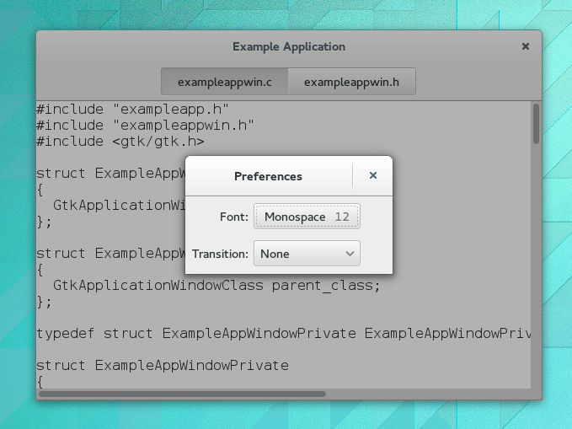

Adding a search bar
We continue to flesh out the functionality of our application. For now, we add search. GTK+ supports this with GtkSearchEntry and GtkSearchBar. The search bar is a widget that can slide in from the top to present a search entry.
We add a toggle button to the header bar, which can be used to slide out the search bar below the header bar.
<?xml version="1.0" encoding="UTF-8"?>
<interface>
<!-- interface-requires gtk+ 3.8 -->
<template class="ExampleAppWindow" parent="GtkApplicationWindow">
<property name="title" translatable="yes">Example Application</property>
<property name="default-width">600</property>
<property name="default-height">400</property>
<child>
<object class="GtkBox" id="content_box">
<property name="visible">True</property>
<property name="orientation">vertical</property>
<child>
<object class="GtkHeaderBar" id="header">
<property name="visible">True</property>
<child type="title">
<object class="GtkStackSwitcher" id="tabs">
<property name="visible">True</property>
<property name="stack">stack</property>
</object>
</child>
<child>
<object class="GtkToggleButton" id="search">
<property name="visible">True</property>
<property name="sensitive">False</property>
<style>
<class name="image-button"/>
</style>
<child>
<object class="GtkImage" id="search-icon">
<property name="visible">True</property>
<property name="icon-name">edit-find-symbolic</property>
<property name="icon-size">1</property>
</object>
</child>
</object>
<packing>
<property name="pack-type">end</property>
</packing>
</child>
</object>
</child>
<child>
<object class="GtkSearchBar" id="searchbar">
<property name="visible">True</property>
<child>
<object class="GtkSearchEntry" id="searchentry">
<signal name="search-changed" handler="search_text_changed"/>
<property name="visible">True</property>
</object>
</child>
</object>
</child>
<child>
<object class="GtkStack" id="stack">
<signal name="notify::visible-child" handler="visible_child_changed"/>
<property name="visible">True</property>
</object>
</child>
</object>
</child>
</template>
</interface>
Implementing the search needs quite a few code changes that we are not going to completely go over here. The central piece of the search implementation is a signal handler that listens for text changes in the search entry.
...

static void
search_text_changed (GtkEntry *entry,
ExampleAppWindow *win)
{
ExampleAppWindowPrivate *priv;
const gchar *text;
GtkWidget *tab;
GtkWidget *view;
GtkTextBuffer *buffer;
GtkTextIter start, match_start, match_end;

text = gtk_entry_get_text (entry);

if (text[0] == '\0')
return;

priv = example_app_window_get_instance_private (win);

tab = gtk_stack_get_visible_child (GTK_STACK (priv->stack));
view = gtk_bin_get_child (GTK_BIN (tab));
buffer = gtk_text_view_get_buffer (GTK_TEXT_VIEW (view));

/* Very simple-minded search implementation */
gtk_text_buffer_get_start_iter (buffer, &start);
if (gtk_text_iter_forward_search (&start, text, GTK_TEXT_SEARCH_CASE_INSENSITIVE,
&match_start, &match_end, NULL))
{
gtk_text_buffer_select_range (buffer, &match_start, &match_end);
gtk_text_view_scroll_to_iter (GTK_TEXT_VIEW (view), &match_start,
0.0, FALSE, 0.0, 0.0);
}
}

static void
example_app_window_init (ExampleAppWindow *win)
{

...

gtk_widget_class_bind_template_callback (GTK_WIDGET_CLASS (class), search_text_changed);

...

}

...

(full source)
With the search bar, our application now looks like this:
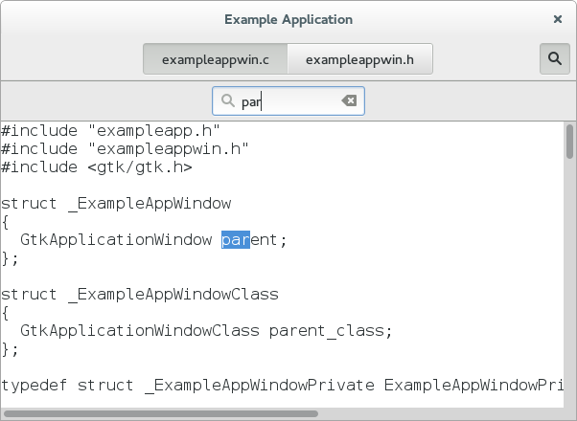

Adding a side bar
As another piece of functionality, we are adding a sidebar, which demonstrates GtkMenuButton, GtkRevealer and GtkListBox.
<?xml version="1.0" encoding="UTF-8"?>
<interface>
<!-- interface-requires gtk+ 3.8 -->
<template class="ExampleAppWindow" parent="GtkApplicationWindow">
<property name="title" translatable="yes">Example Application</property>
<property name="default-width">600</property>
<property name="default-height">400</property>
<child>
<object class="GtkBox" id="content_box">
<property name="visible">True</property>
<property name="orientation">vertical</property>
<child>
<object class="GtkHeaderBar" id="header">
<property name="visible">True</property>
<child type="title">
<object class="GtkStackSwitcher" id="tabs">
<property name="visible">True</property>
<property name="stack">stack</property>
</object>
</child>
<child>
<object class="GtkToggleButton" id="search">
<property name="visible">True</property>
<property name="sensitive">False</property>
<style>
<class name="image-button"/>
</style>
<child>
<object class="GtkImage" id="search-icon">
<property name="visible">True</property>
<property name="icon-name">edit-find-symbolic</property>
<property name="icon-size">1</property>
</object>
</child>
</object>
<packing>
<property name="pack-type">end</property>
</packing>
</child>
<child>
<object class="GtkMenuButton" id="gears">
<property name="visible">True</property>
<property name="direction">none</property>
<property name="use-popover">True</property>
<style>
<class name="image-button"/>
</style>
</object>
<packing>
<property name="pack-type">end</property>
</packing>
</child>
</object>
</child>
<child>
<object class="GtkSearchBar" id="searchbar">
<property name="visible">True</property>
<child>
<object class="GtkSearchEntry" id="searchentry">
<signal name="search-changed" handler="search_text_changed"/>
<property name="visible">True</property>
</object>
</child>
</object>
</child>
<child>
<object class="GtkBox" id="hbox">
<property name="visible">True</property>
<child>
<object class="GtkRevealer" id="sidebar">
<property name="visible">True</property>
<property name="transition-type">slide-right</property>
<child>
<object class="GtkScrolledWindow" id="sidebar-sw">
<property name="visible">True</property>
<property name="hscrollbar-policy">never</property>
<property name="vscrollbar-policy">automatic</property>
<child>
<object class="GtkListBox" id="words">
<property name="visible">True</property>
<property name="selection-mode">none</property>
</object>
</child>
</object>
</child>
</object>
</child>
<child>
<object class="GtkStack" id="stack">
<signal name="notify::visible-child" handler="visible_child_changed"/>
<property name="visible">True</property>
</object>
</child>
</object>
</child>
</object>
</child>
</template>
</interface>
The code to populate the sidebar with buttons for the words found in each file is a little too involved to go into here. But we'll look at the code to add the gears menu.
As expected by now, the gears menu is specified in a GtkBuilder ui file.
<?xml version="1.0"?>
<interface>
<!-- interface-requires gtk+ 3.0 -->
<menu id="menu">
<section>
<item>
<attribute name="label" translatable="yes">_Words</attribute>
<attribute name="action">win.show-words</attribute>
</item>
</section>
</menu>
</interface>
To connect the menuitem to the show-words setting, we use a GAction corresponding to the given GSettings key.
...

static void
example_app_window_init (ExampleAppWindow *win)
{

...

builder = gtk_builder_new_from_resource ("/org/gtk/exampleapp/gears-menu.ui");
menu = G_MENU_MODEL (gtk_builder_get_object (builder, "menu"));
gtk_menu_button_set_menu_model (GTK_MENU_BUTTON (priv->gears), menu);
g_object_unref (builder);

action = g_settings_create_action (priv->settings, "show-words");
g_action_map_add_action (G_ACTION_MAP (win), action);
g_object_unref (action);
}

...

(full source)
What our application looks like now:
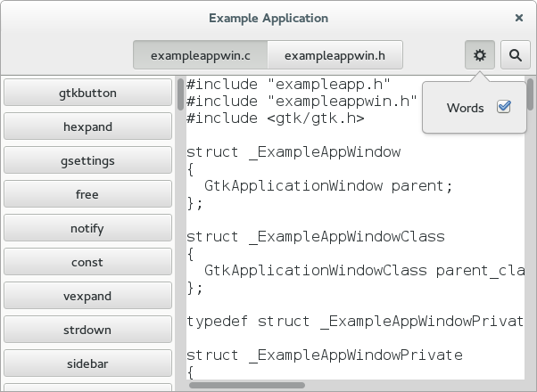

Properties
Widgets and other objects have many useful properties.
Here we show some ways to use them in new and flexible ways, by wrapping them in actions with GPropertyAction or by binding them with GBinding.
To set this up, we add two labels to the header bar in our window template, named lines_label and lines, and bind them to struct members in the private struct, as we've seen a couple of times by now.
We add a new "Lines" menu item to the gears menu, which triggers the show-lines action:
<?xml version="1.0"?>
<interface>
<!-- interface-requires gtk+ 3.0 -->
<menu id="menu">
<section>
<item>
<attribute name="label" translatable="yes">_Words</attribute>
<attribute name="action">win.show-words</attribute>
</item>
<item>
<attribute name="label" translatable="yes">_Lines</attribute>
<attribute name="action">win.show-lines</attribute>
</item>
</section>
</menu>
</interface>
To make this menu item do something, we create a property action for the visible property of the lines label, and add it to the actions of the window. The effect of this is that the visibility of the label gets toggled every time the action is activated.
Since we want both labels to appear and disappear together, we bind the visible property of the lines_label widget to the same property of the lines widget.
...

static void
example_app_window_init (ExampleAppWindow *win)
{
...

action = (GAction*) g_property_action_new ("show-lines", priv->lines, "visible");
g_action_map_add_action (G_ACTION_MAP (win), action);
g_object_unref (action);

g_object_bind_property (priv->lines, "visible",
priv->lines_label, "visible",
G_BINDING_DEFAULT);
}

...

(full source)
We also need a function that counts the lines of the currently active tab, and updates the lines label. See the full source if you are interested in the details.
This brings our example application to this appearance:
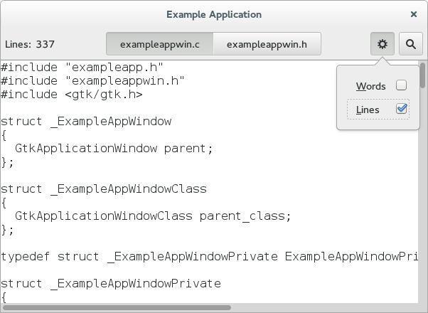

Header bar
Our application already uses a GtkHeaderBar, but so far it still gets a 'normal' window titlebar on top of that. This is a bit redundant, and we will now tell GTK+ to use the header bar as replacement for the titlebar. To do so, we move it around to be a direct child of the window, and set its type to be titlebar.
<?xml version="1.0" encoding="UTF-8"?>
<interface>
<!-- interface-requires gtk+ 3.8 -->
<template class="ExampleAppWindow" parent="GtkApplicationWindow">
<property name="title" translatable="yes">Example Application</property>
<property name="default-width">600</property>
<property name="default-height">400</property>
<child type="titlebar">
<object class="GtkHeaderBar" id="header">
<property name="visible">True</property>
<property name="show-close-button">True</property>
<child>
<object class="GtkLabel" id="lines_label">
<property name="visible">False</property>
<property name="label" translatable="yes">Lines:</property>
</object>
<packing>
<property name="pack-type">start</property>
</packing>
</child>
<child>
<object class="GtkLabel" id="lines">
<property name="visible">False</property>
</object>
<packing>
<property name="pack-type">start</property>
</packing>
</child>
<child type="title">
<object class="GtkStackSwitcher" id="tabs">
<property name="visible">True</property>
<property name="stack">stack</property>
</object>
</child>
<child>
<object class="GtkToggleButton" id="search">
<property name="visible">True</property>
<property name="sensitive">False</property>
<style>
<class name="image-button"/>
</style>
<child>
<object class="GtkImage" id="search-icon">
<property name="visible">True</property>
<property name="icon-name">edit-find-symbolic</property>
<property name="icon-size">1</property>
</object>
</child>
</object>
<packing>
<property name="pack-type">end</property>
</packing>
</child>
<child>
<object class="GtkMenuButton" id="gears">
<property name="visible">True</property>
<property name="direction">none</property>
<property name="use-popover">True</property>
<style>
<class name="image-button"/>
</style>
</object>
<packing>
<property name="pack-type">end</property>
</packing>
</child>
</object>
</child>
<child>
<object class="GtkBox" id="content_box">
<property name="visible">True</property>
<property name="orientation">vertical</property>
<child>
<object class="GtkSearchBar" id="searchbar">
<property name="visible">True</property>
<child>
<object class="GtkSearchEntry" id="searchentry">
<signal name="search-changed" handler="search_text_changed"/>
<property name="visible">True</property>
</object>
</child>
</object>
</child>
<child>
<object class="GtkBox" id="hbox">
<property name="visible">True</property>
<child>
<object class="GtkRevealer" id="sidebar">
<property name="visible">True</property>
<property name="transition-type">slide-right</property>
<child>
<object class="GtkScrolledWindow" id="sidebar-sw">
<property name="visible">True</property>
<property name="hscrollbar-policy">never</property>
<property name="vscrollbar-policy">automatic</property>
<child>
<object class="GtkListBox" id="words">
<property name="visible">True</property>
<property name="selection-mode">none</property>
</object>
</child>
</object>
</child>
</object>
</child>
<child>
<object class="GtkStack" id="stack">
<signal name="notify::visible-child" handler="visible_child_changed"/>
<property name="visible">True</property>
</object>
</child>
</object>
</child>
</object>
</child>
</template>
</interface>
A small extra bonus of using a header bar is that we get a fallback application menu for free. Here is how the application now looks, if this fallback is used.
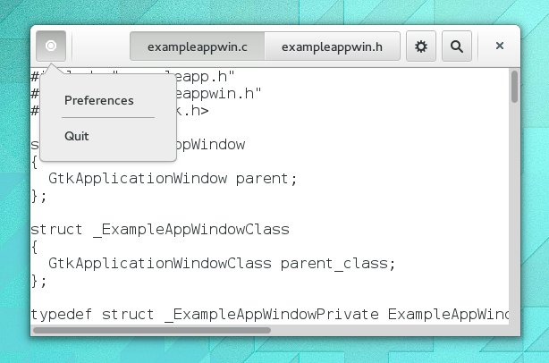
If we set up the window icon for our window, the menu button will use that instead of the generic placeholder icon you see here.

